Assessment: Assignment 02
Student Name: Vasukumar Patel
Lab Professor Name: Syed Bilgrami
Lab Section Number: 343
Due Date: November 24th

Task 1: Understand the problem

- checkWithinTolerance() of class BatteryChecker:
Since method has a Boolean data type, I will declare two variables for height and diameter which will have Boolean data type. They will return Boolean values true or false. I will use if-then-else-endif condition in order to return the correct value.

- main() of class Driver:
I will use static method to call method from user class. Since they are overloaded methods, I will provide parameters according to the requirements. Then, I will use object to call my written code from batteryChecker class. Then, I will apply do while loop. Since I do not know that how many times the loop will repeat, I will not use while loop according to the lecture’s material. Also, I will print my name as well as how many batteries are not within the tolerance. That, I will do by declaring a variable and give it 0 value. and, and I will use operator to increase the number in the if-then-else-endif statement.

Task 2-1: Detailed UML Class Diagrams
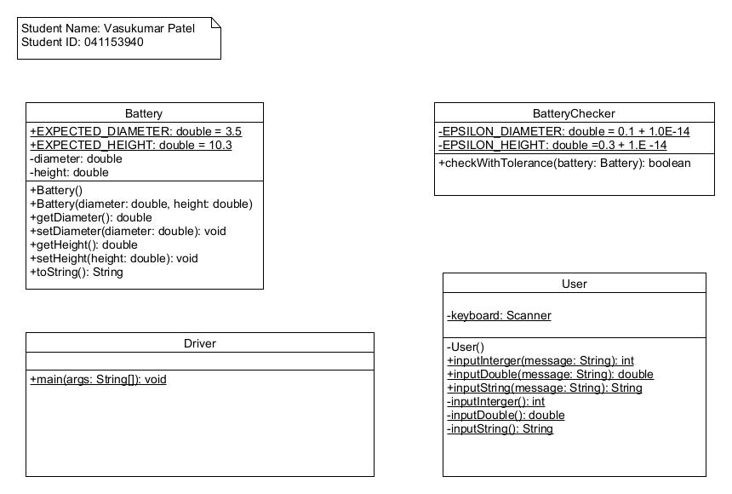

Task 2-2: Flowcharts

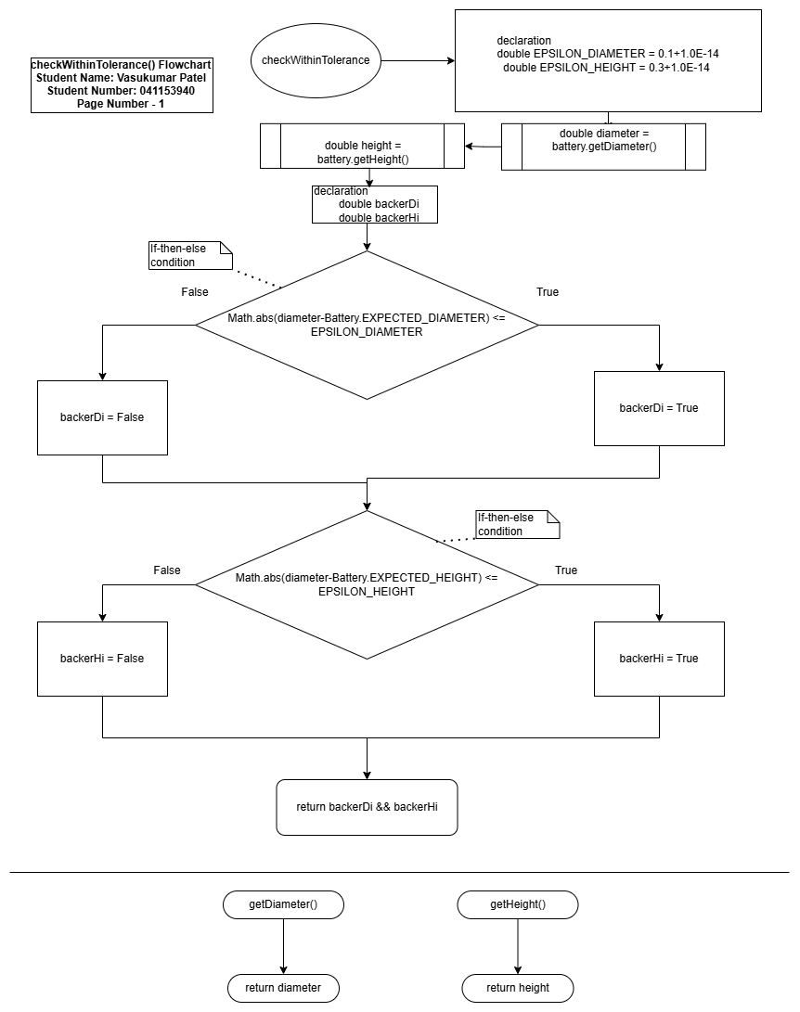

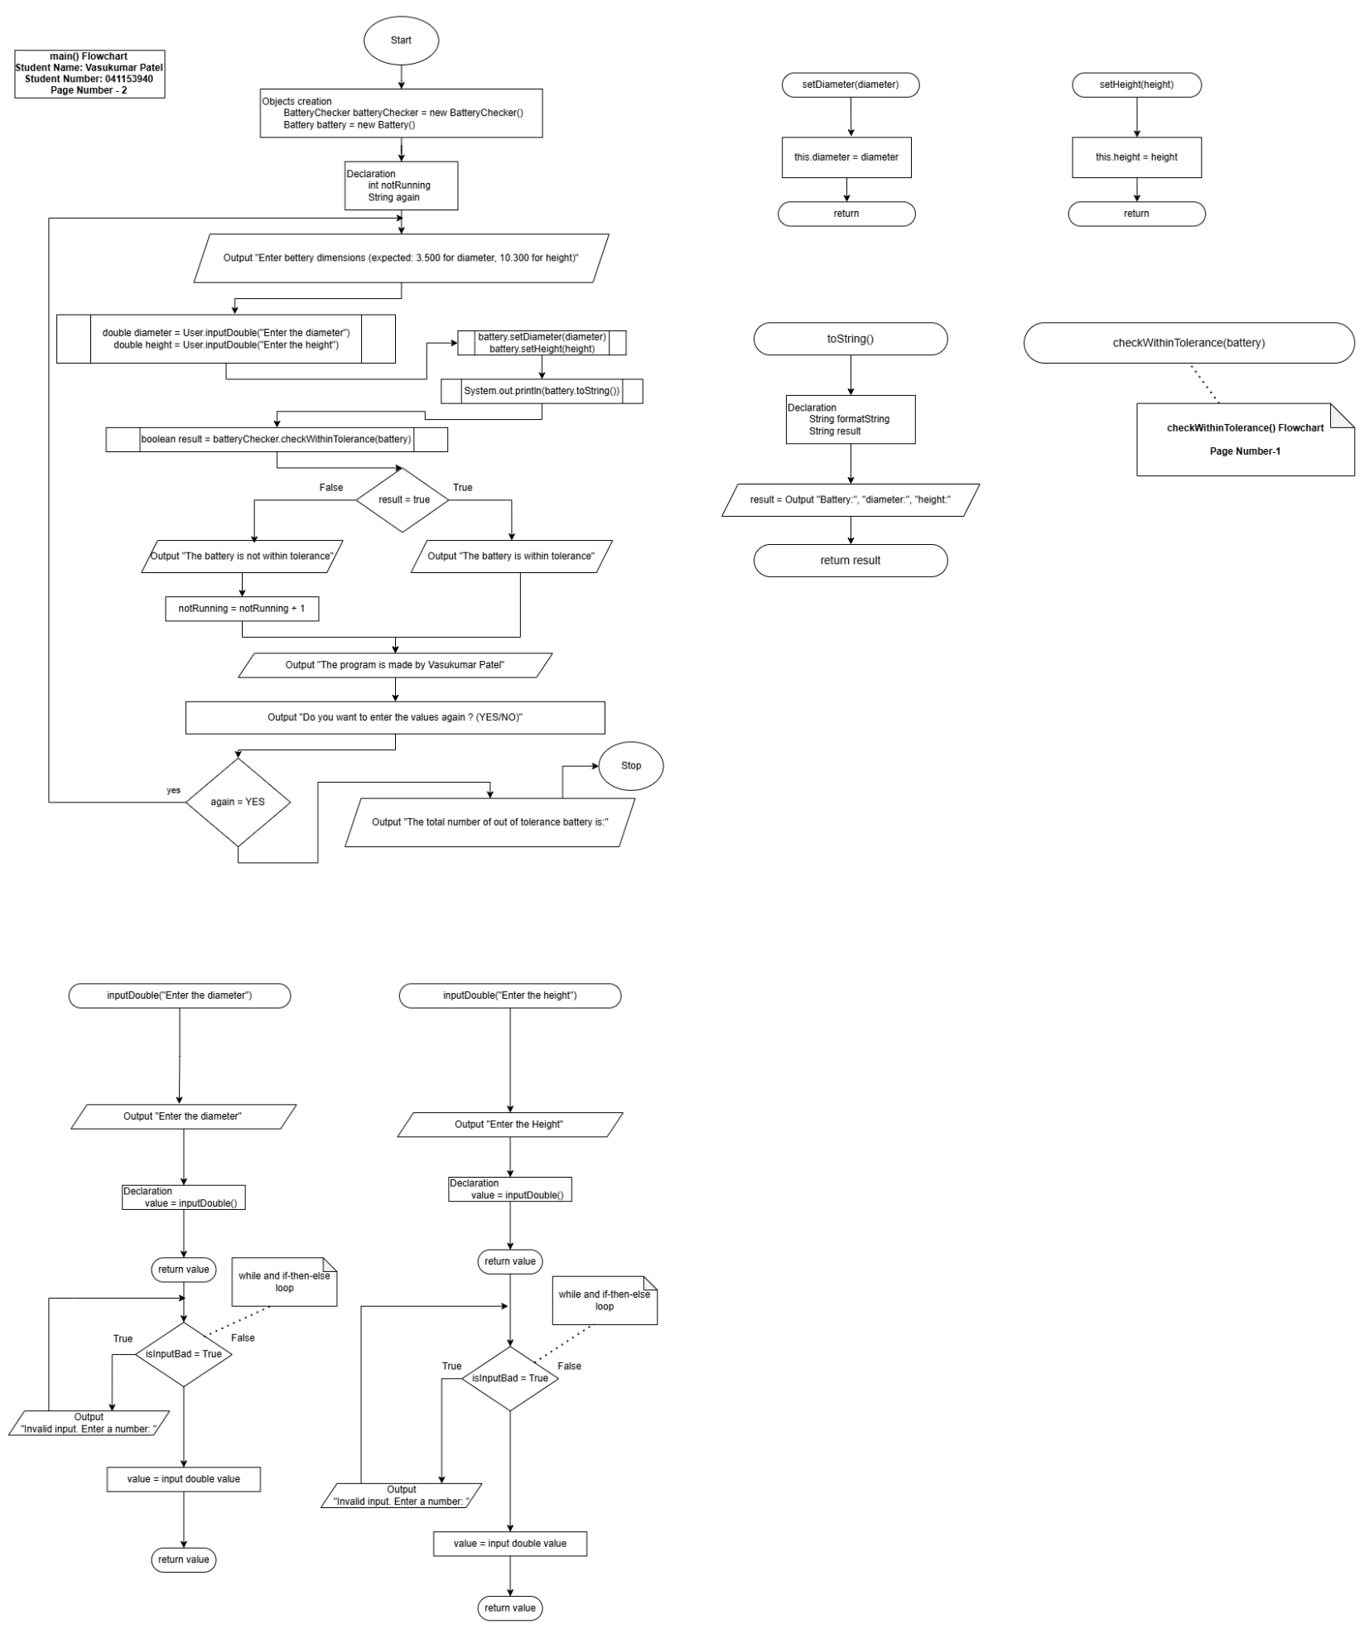

Task 3: Test Algorithm with Simple Inputs

Table 1: Test Plan for method main for the repetition structure logic (looping tests)
Input | Expected Output | Actual Output | Description
3.5  10.3  YES | Enter bettery dimensions (expected: 3.500 for diameter, 10.300 for height)  Enter the diameter3.5  Enter the height10.3  Battery: diameter 3.50, height 10.30  The battery is within tolerance  The program is made by Vasukumar Patel  Do you want to enter the values again ? (YES/NO)YES  Enter bettery dimensions (expected: 3.500 for diameter, 10.300 for height) | Enter bettery dimensions (expected: 3.500 for diameter, 10.300 for height)  Enter the diameter3.5  Enter the height10.3  Battery: diameter 3.50, height 10.30  The battery is within tolerance  The program is made by Vasukumar Patel  Do you want to enter the values again ? (YES/NO)YES  Enter bettery dimensions (expected: 3.500 for diameter, 10.300 for height) | The program logic is correct, and it is following the correct sequences. When I wrote yes, the program repeat the code again as expected.
3.5  10.3  NO | Enter bettery dimensions (expected: 3.500 for diameter, 10.300 for height)  Enter the diameter3.5  Enter the height10.3  Battery: diameter 3.50, height 10.30  The battery is within tolerance  The program is made by Vasukumar Patel  Do you want to enter the values again ? (YES/NO)no  The total number of out of tolerance battery is: 0 | Enter bettery dimensions (expected: 3.500 for diameter, 10.300 for height)  Enter the diameter3.5  Enter the height10.3  Battery: diameter 3.50, height 10.30  The battery is within tolerance  The program is made by Vasukumar Patel  Do you want to enter the values again ? (YES/NO)no  The total number of out of tolerance battery is: 0 | The program is following the correct sequence of the flowchart, and the results are correct. When I wrote no, it stops the program and gave me the total number of out of tolerance battery. Also, the program is ignoring the cases for YES and NO as expected.
3.5  10.3  maybe | Enter bettery dimensions (expected: 3.500 for diameter, 10.300 for height)  Enter the diameter3.5  Enter the height10.3  Battery: diameter 3.50, height 10.30  The battery is within tolerance  The program is made by Vasukumar Patel  Do you want to enter the values again ? (YES/NO)maybe  The total number of out of tolerance battery is: 0 | Enter bettery dimensions (expected: 3.500 for diameter, 10.300 for height)  Enter the diameter3.5  Enter the height10.3  Battery: diameter 3.50, height 10.30  The battery is within tolerance  The program is made by Vasukumar Patel  Do you want to enter the values again ? (YES/NO)maybe  The total number of out of tolerance battery is: 0 | In the TODO comments, there is mentioned that you only have to repeat the driver program when user type “YES.” If the user does not write “yes”. The program will stop, and it will show the total number of out of tolerance battery as expected.

Table 2: Test Plan for method main for verifying the battery tolerance check.
- Reminder: Highlight in your testing table the relevant items you are testing and validating, as shown in the sample.
Input | Expected Output | Actual Output | Description
3.5  10.0 | Enter bettery dimensions (expected: 3.500 for diameter, 10.300 for height)  Enter the diameter3.5  Enter the height10.0  Battery: diameter 3.50, height 10.00  The battery is within tolerance  The program is made by Vasukumar Patel  Do you want to enter the values again ? (YES/NO) | Enter bettery dimensions (expected: 3.500 for diameter, 10.300 for height)  Enter the diameter3.5  Enter the height10.0  Battery: diameter 3.50, height 10.00  The battery is within tolerance  The program is made by Vasukumar Patel  Do you want to enter the values again ? (YES/NO) | As expected, the program output is within tolerance because the entered height is within tolerance. There is 0.3 difference.
3.5  10.9 | Enter bettery dimensions (expected: 3.500 for diameter, 10.300 for height)  Enter the diameter3.5  Enter the height10.9  Battery: diameter 3.50, height 10.90  The battery is not within tolerance  The program is made by Vasukumar Patel  Do you want to enter the values again ? (YES/NO) | Enter bettery dimensions (expected: 3.500 for diameter, 10.300 for height)  Enter the diameter3.5  Enter the height10.9  Battery: diameter 3.50, height 10.90  The battery is not within tolerance  The program is made by Vasukumar Patel  Do you want to enter the values again ? (YES/NO) | As expected, the program output is not within tolerance because height at above the tolerance. There is 0.6 difference.
3.5  -10.3 | Enter bettery dimensions (expected: 3.500 for diameter, 10.300 for height)  Enter the diameter3.5  Enter the height-11.3  Battery: diameter 3.50, height -11.30  The battery is not within tolerance  The program is made by Vasukumar Patel  Do you want to enter the values again ? (YES/NO) | Enter bettery dimensions (expected: 3.500 for diameter, 10.300 for height)  Enter the diameter3.5  Enter the height-11.3  Battery: diameter 3.50, height -11.30  The battery is not within tolerance  The program is made by Vasukumar Patel  Do you want to enter the values again ? (YES/NO) | As expected, the program output is not within tolerance because of the negative value. The program is working perfectly for negative height as the difference is negative one (-1).

Task 5: Five screenshots of validating the Algorithm Test Table
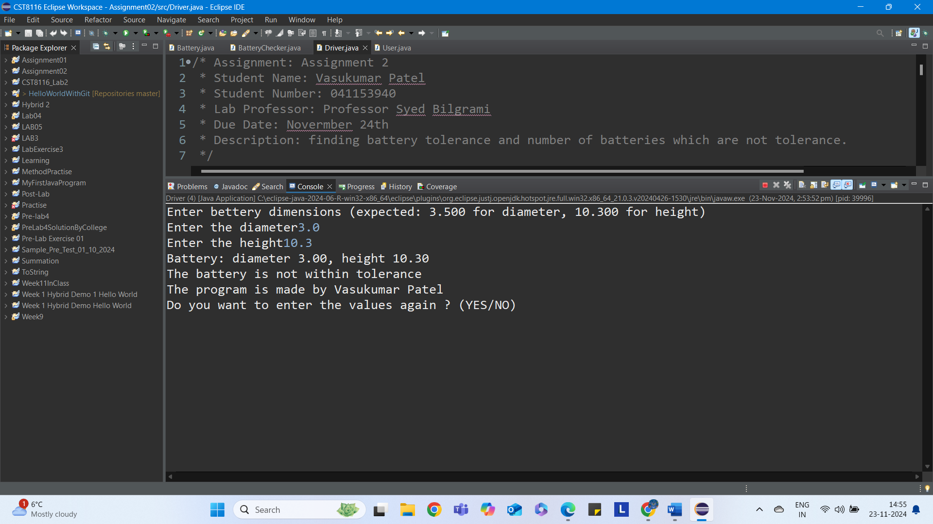

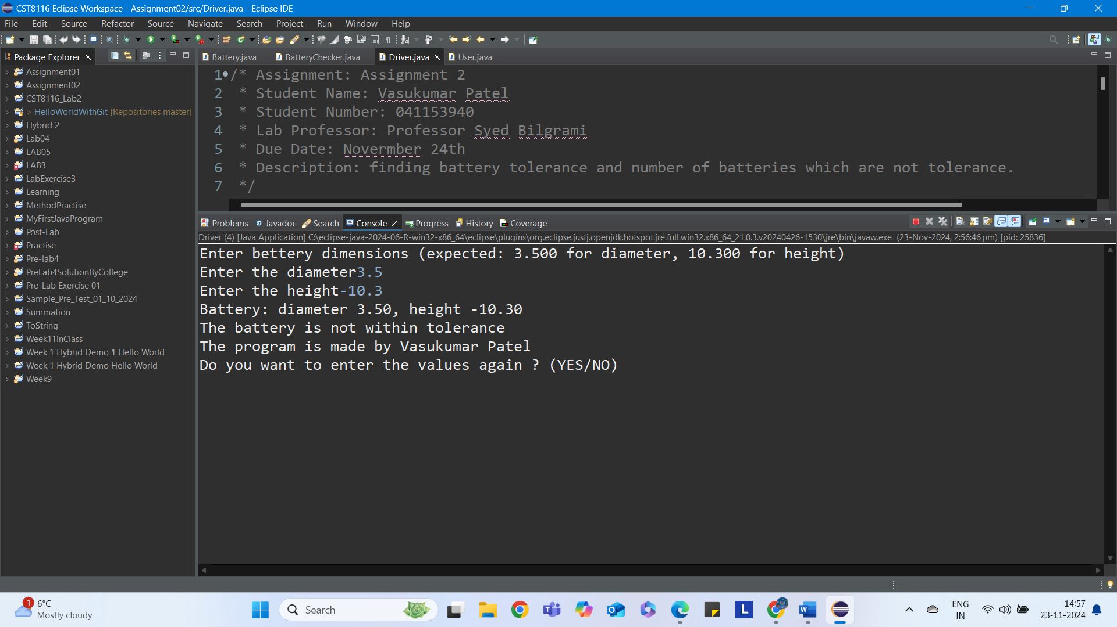

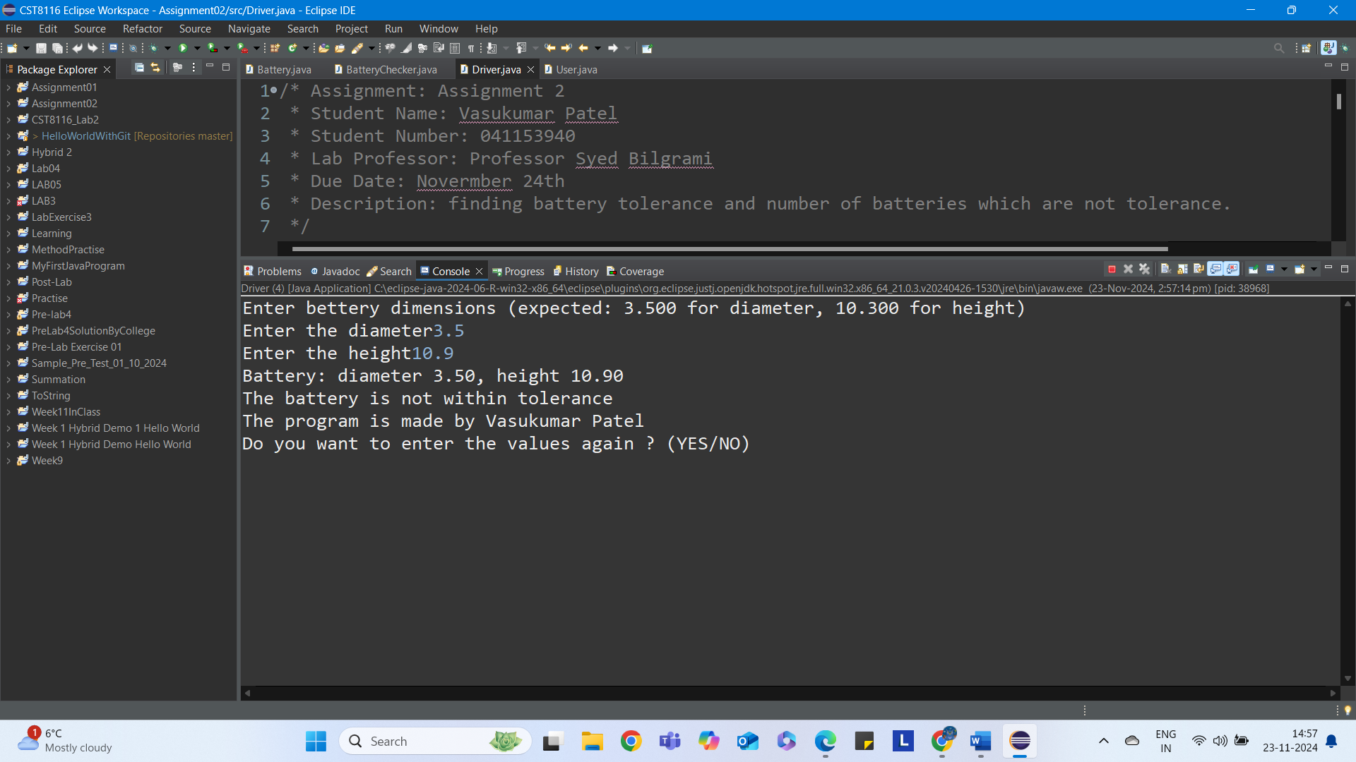

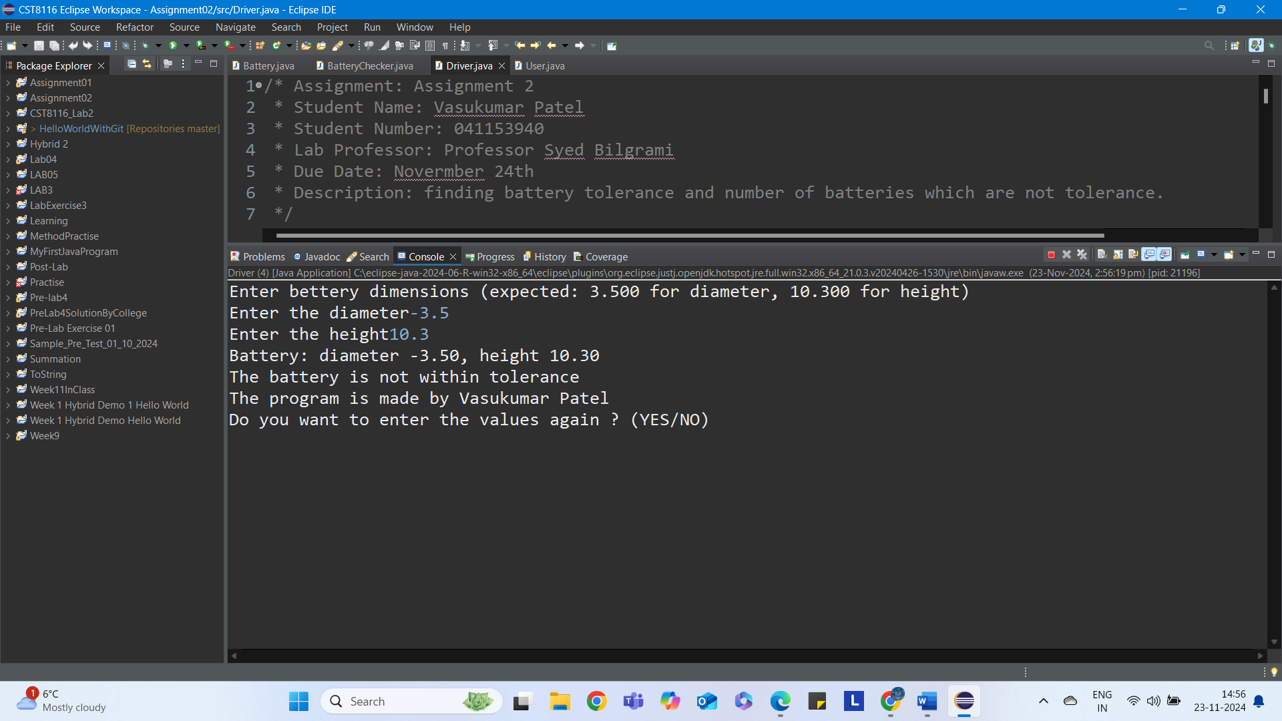

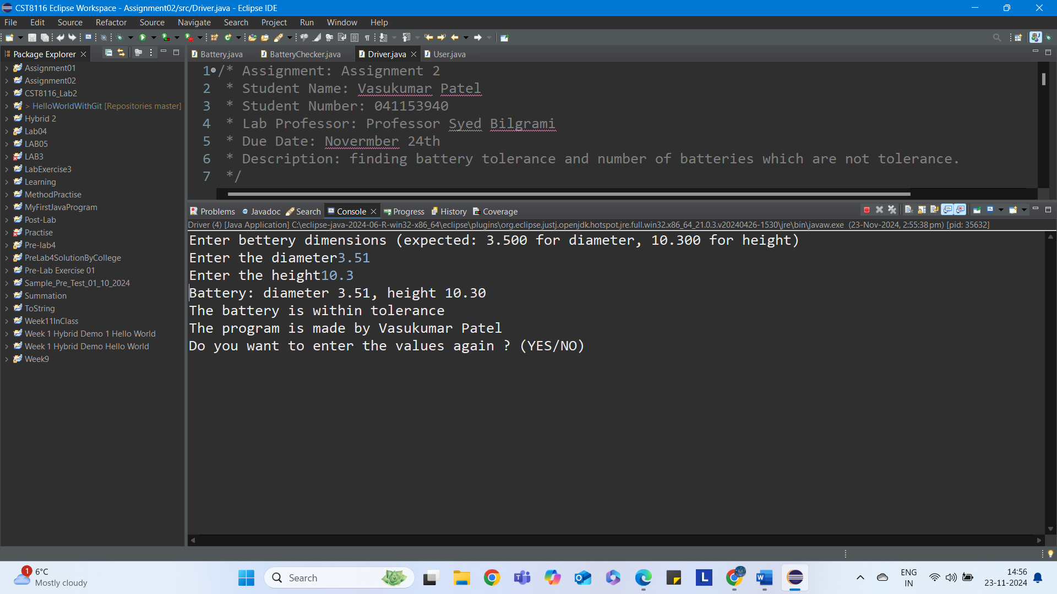

References

